* Software engineering assignment

Q1 What is software what is software engineering

ans=software is set of instructions ,data or program

Used to operate computer

=software engineering is deal with design

Maintenance and testing of the software as well.

=engineer apply engineering principle and knowledge of

Programming language to make software

Q2 Explain type of software

ans=there are generally two type of software which include

Application software and system software

=application software:-application software is a computer

Software that used to used to perform specific task for the user

General purpose software like ms word

Customize software zomato

:=system software

this software program are designed to run

Computer application program and hardware

:-it control all the operation of the computer hardware

And provide the environment to other type of software to work.os is the best ex of the system software

:operating system

:language processor

:device driver

Q3 What is sdlc.explain each phase of sdlc

ans=:Software Development Life Cycle (SDLC) is a framework that defines the steps involved in the development of software at each phase. It covers the detailed plan for building, deploying and maintaining the software.

=**Below is the diagrammatic representation of the SDLC cycle:**

[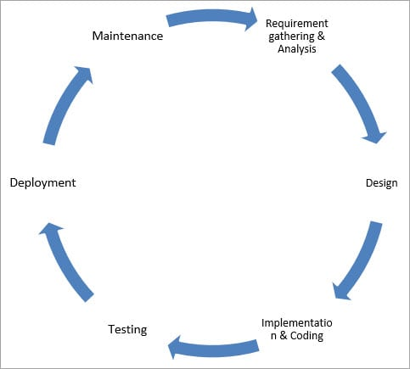](https://www.softwaretestinghelp.com/wp-content/qa/uploads/2018/04/SDLC-Cycle.jpg)

Q4 What is dfd.create dfd diagram on flipkart

Ans =:Data flow diagrams are used to graphically represent the flow of data in a business information system. DFD describes the processes that are involved in a system to transfer data from the input to the file storage and reports generation.

Data flow diagrams can be divided into logical and physical. The logical data flow diagram describes flow of data through a system to perform certain functionality of a business. The physical data flow diagram describes the implementation of the logical data flow.

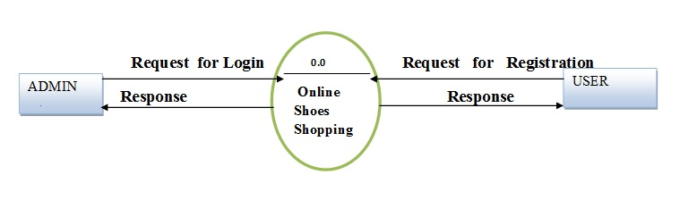

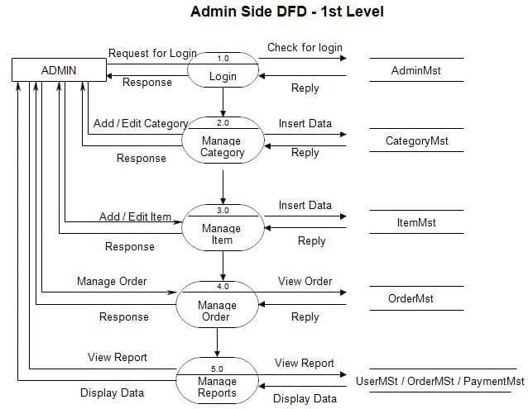

Q5 What is flow chart.create flow chart to Make addition of two number

Ans =**Flowcharts** are nothing but the graphical representation of the data or the algorithm for a better understanding of the code visually. It displays step-by-step solutions to a problem, algorithm, or process. It is a pictorial way of representing steps that are preferred by most beginner-level programmers to understand algorithms of computer science, thus it contributes to troubleshooting the issues in the algorithm. A flowchart is a picture of boxes that indicates the process flow sequentially. Since a flowchart is a pictorial representation of a process or algorithm, it’s easy to interpret and understand the process.

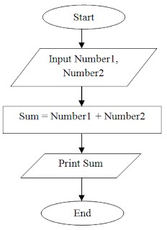

Q 6 what is use case diagram.create use case on bill payment on paytm

Ans =A use case is a concept used in software development, product design, and other fields to describe how a system can be used to achieve specific goals or tasks. It outlines the interactions between users or actors and the system to achieve a specific outcome.

